THE 2015 MARTÍN VIVALDI AWARD

The 2015 MARTÍN VIVALDI Award offers financial assistance to the winner to attend the EUROCLAY 2015 to be held in Edinburgh (UK).

The closing date for reception of manuscripts will be 1st March 2015.

AIM

The Martín Vivaldi Award is an European award, sponsored by the European Clay Groups Association (ECGA) and financially supported by Sociedad Española de Arcillas - SEA (Spanish Clay Society), to offer financial assistance to the recipient, who must be member of one of the ECGA Societies, with the aim to enable him/her to participate in an EUROCLAY Meeting for the purpose of presenting his/her paper.

RULES

- Candidates must submit an electronic copy, preferably a pdf file, of approximately 1500 to 2000 words in English on a topic relevant to one of the sessions of the Meeting. The paper should be written in a format acceptable for international journals. Assessment will be on scientific content only and the winner will be expected to present his/her paper at the Meeting.

- The award consists of an honorarium of 1.000 Euros to contribute to the recipient to cover the expenses of the registration fee to the Meeting, travel and hotel expenses for attending the Euroclay Meeting, and a certificate. The award will not be made if it is considered that candidates do not reach the required standard.

- Person eligible for the award must be under 35 years of age and belong to one European National Group affiliated to the ECGA on the closing date for submissions.

- The selection committee shall consist of the President of ECGA (Chair), three members nominated by the ECGA, and the Past-president of the Spanish Clay Society, who will act as Secretary.

- The attached form must be completed and returned to the secretary of the selection committee with each entry to arrive before the official closing date. The candidates must note that the deadline will be strictly observed.

- The winning paper should be submitted for publication in Clay Minerals

 | THE 2015 MARTÍN VIVALDI AWARD  APPLICATION FORM | 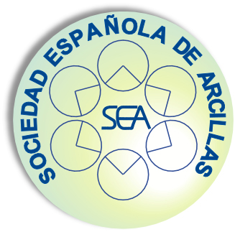

I have read the regulations governing the above Award and in conformity therewith submit a paper entitled:

My date of birth is: (day/month/year)

I belong to the European Clay Group:
(please include certificate from your Society/National group)

I agree to abide by the rules governing the Award and accept that the examiners decision is final.

Date: Signature:

Address:

N.B.: If the candidate is not the sole author of the paper, a statement from the co-author(s) is required specifying the candidate’s contribution to the paper.

Documentation should be sent by e-mail to the Secretary of the Selection Committee (msuarez@usal.es, Mercedes Suárez) with copy to the general address of the Spanish Clay Society (sea@sea-arcillas.es):

